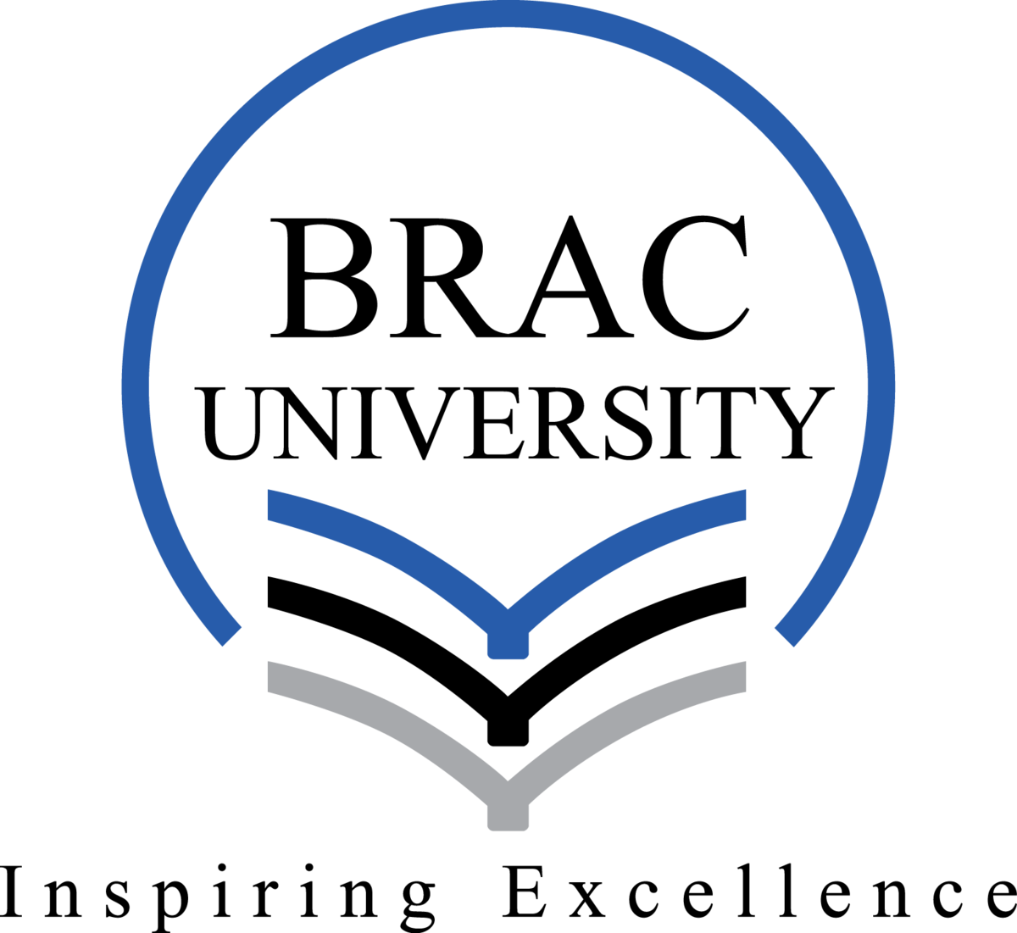

Name of the Student: Mehedi Hasan Rowdro
ID: 24101226
Semester: Fall2024
Section: 01
Date: 09.01.2025

A. On November 14th, during our Social Learning Lab (SLL) day, we took part in cleaning the Durjoy and Durbar fields. We worked together to remove dead leaves from the ground and used brooms to sweep the area thoroughly. It was a unique experience where we bonded with friends while engaging in meaningful work. Although it felt like a fun activity, it also gave us a deeper understanding of the challenges faced by workers who do such jobs daily. This program highlighted the importance of community responsibility. As students, it allowed us to step outside our usual routines and actively contribute to our environment. Simple tasks like cleaning reminded us of the ethical responsibility to keep public spaces clean and respect those who maintain them. Experiencing the labor firsthand made us appreciate the hard work of cleaners, often unnoticed in their daily efforts.

B. From an ethical perspective, this activity is related to virtue ethics, where the development of good habits and character building is emphasized. In this initiative, we applied virtues such as teamwork, and care in the community. According to utilitarian ethics, our collective effort created greater happiness for greater number of people by improving the cleanliness and usability of the fields. This activity also demonstrated to the concept of deontological ethics, which emphasizes doing one’s duty and following moral rules regardless of personal benefit. By participating in this initiative, we fulfilled our moral duty to care for shared spaces and uphold community standards. This approach also reinforced the idea that every individual has a role to play in maintaining cleanliness and respecting labor.

